

# Documentation Docker + Fluree (Windows):

Table of Contents

Documentation Docker + Fluree (Windows): 1

Creating a Fluree server using Docker 1

Creating a Ledger in Fluree Server using Postman: 4

Using Fluree Ledger Image in Docker (Outdated) 5

Working with Fluree Admin Console (Outdated): 7

Adding Data: 7

Docker Networks (Incomplete): 10

Using Fluree ledger and Server together using Docker images : 10

Important Notes: 11

Navigating in a CLI Windows: 11

# Creating a Fluree server using Docker

Note: Please ensure that you have Docker installed.

There is 2 ways to create a server using the Fluree Server Image, the first is using the Command Line interface or CLI for short (Recommended) the second is through the Docker desktop application.

1. **Using a CLI to create a server:**

* In the CLI run the following command:
* docker run --name fluree_server3 -p 58090:8090 fluree/server
* Important:
  + The “-p” command specifies the port the server will use locally.
  + The text following “–name” is the name of the Docker container pulled from the Fluree server image. This can be changed depending on the user’s preference.
  + Docker will automatically pull the fluree/server and run it if it is not found on your local device.
  + In your CLI you can type “**docker ps**” this should show the running server.
  + This is what it will look like inside of the Docker Desktop Application (If you are using it):

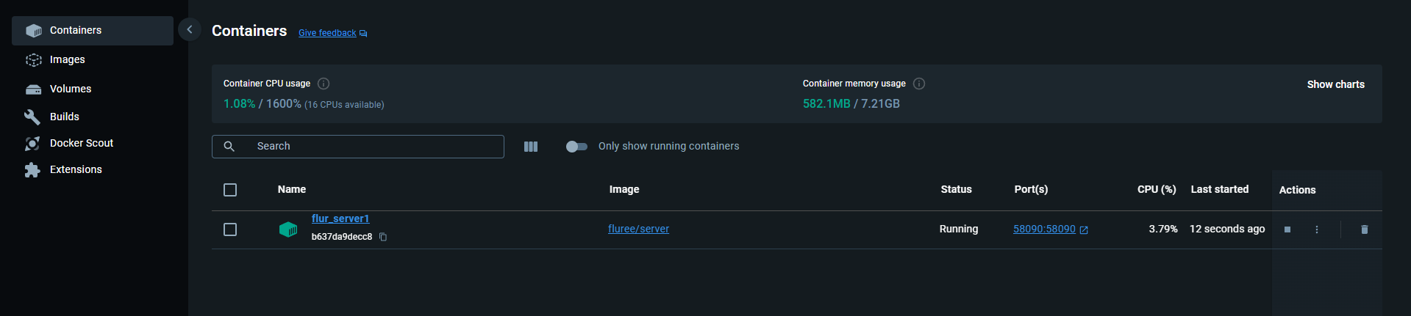

Figure 1 In the docker desktop application the container you’ve just created will appear

1. Using Docker Desktop Application -Optional (Recommended to use 1):
   1. Running the command (IN CLI): **docker pull fluree/server**
   2. In Docker Desktop navigate to “**images**” on the left side of the window.
      1. Fluree Server image will be in the list of Docker images, click the “**play**” icon:

* 1. Configure the container settings:

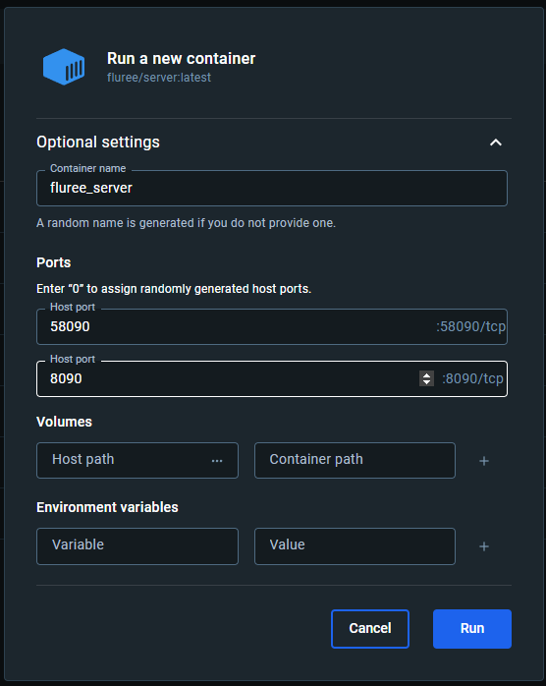

* 1. Your server will be up and running.

## Creating a Ledger in Fluree Server using Postman:

* There is a good beginner guide from Fluree to start adding data to server, we are going to use it as a foundation:

<https://next.developers.flur.ee/docs/reference/cookbook/>

* + Click the “Run in Postman” option to view the Fluree “Cookbook” to easily conduct data management using Postman:

* Once you have added the Fluree Workbook on the Postman Website. The Cookbook workbook will also automatically be added to the desktop version of Postman, here you can see a good example on how to query Fluree server.

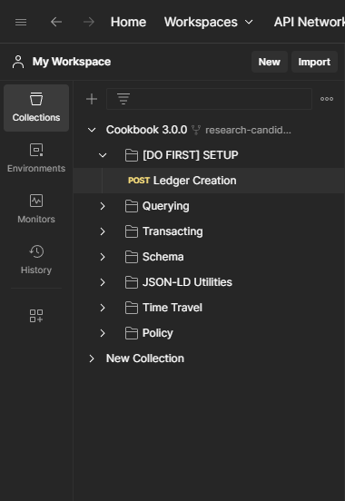

* In the cookbook example, click on [DO FIRST] setup in the left-hand side where the Collections are stated.
* You can edit the values in the Ledger creation space to match your requirements.
* After hitting send you have created a transaction with a unique transaction id which can identify it if needed. You can now query the ledger and perform insert, update and delete operations if needed.

## Using Fluree Ledger Image in Docker (Outdated)

VERY IMPORTANT: We did not proceed to use the Fluree Ledger Image and rather used Fluree server directly. This is only additional information.

* Ensure **Docker** **Desktop** is installed.

1. Open <https://hub.docker.com/r/fluree/ledger> and copy the Docker pull command to copy the image to your local storage: **docker pull fluree/ledger.** Once you have copied the command, paste and run it inside a CLI.

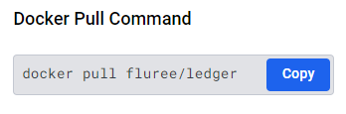

1. Then run the following command in the terminal:

**docker run -p 8090:8090 --name ledger1 fluree/ledger**

//This gives the docker container the name “ledger1”//

1. On the docker desktop application a new container should be up and running called “ledger1” or whatever you have named it. In the Containers widget under port there will be a link for 8090:8090, it may be different if you have assigned a different port in step 2. Click on the link or in your browser type **http://localhost:8090**/.

**Note:**

* If you get the following error, try opening this link in a **different browser** Microsoft Edge worked for me:

1. When you have opened the link in your browser, the following popup will appear, where you must name your network followed by a ‘/’ and lastly the ledger name. The Fluree provides I found to be misleading, it contains capitalised letters**, the application only accepts lowercase letters as input**.

## Working with Fluree Admin Console (Outdated):

VERY IMPORTANT: We did not proceed to use the Fluree Ledger and rather used Fluree server directly.

### Adding Data:

**Using Protocol:**

1. Open a Command Line Interface (CLI), I made use of **PowerShell**. I inserted sample data from using the HTTP API in CLI using the following command:

Invoke-RestMethod -Uri 'http://localhost:32771/fluree/create' `

-Method POST `

-Headers @{ 'Content-Type' = 'application/json' } `

-Body '{"ledger": "cryptids", "insert": {"@id": "my-first cryptid", "name": "Freddy the Yeti"}}'

**Using Admin UI:**

1. In the Transact column paste data in a similar format as the following:

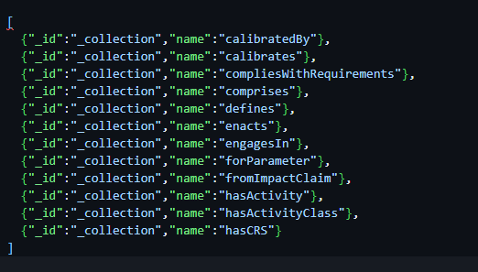

* The data above is Predicates from the AIA ontology, however, Fluree does not want the “name” aspect to be in a URL/URI format. [**http://purl.org/aiaontology#calibratedBy**](http://purl.org/aiaontology#calibratedBy)

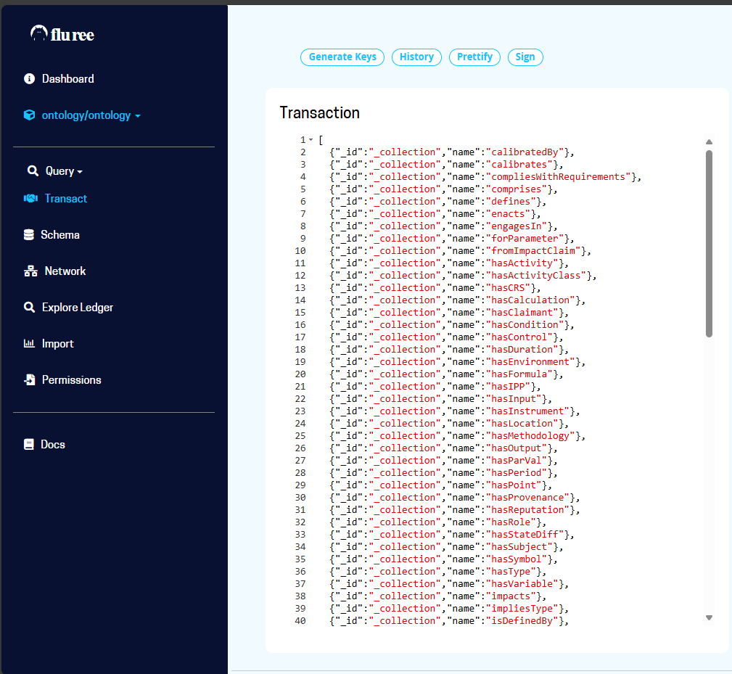

1. Click the “play” icon on the right to process the “transaction”.

From [Fluree Doc using Admin Console](https://docsarchive.flur.ee/docs/overview/fluree_basics/):

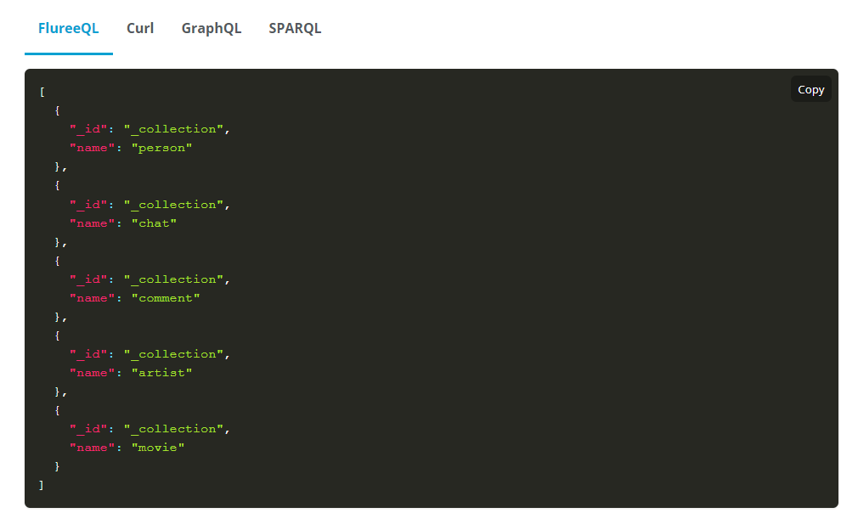

* This adds a Collection “Category” for an entity to be apart of.

# Docker Networks (Incomplete):

* VERY IMPORTANT: We did not proceed to use the Fluree Ledger and rather used Fluree server directly.

## Using Fluree ledger and Server together using Docker images :

version: '3.7'

services:

  fluree_ledger:

    image: fluree/ledger

    container_name: fluree_ledger

    ports:

      - "8090:8090"

    volumes:

      - fluree_ledger_data:/fluree/data

    networks:

      - fluree_network

  fluree_server:

    image: fluree/server

    container_name: fluree_server

    ports:

      - "8080:8080"

    environment:

      - FLUREE_LEDGER_URL=http://fluree_ledger:8090

    depends_on:

      - fluree_ledger

    networks:

      - fluree_network

volumes:

  fluree_ledger_data:

networks:

  fluree_network:

* This is the compose.yml file, required to create a **bridging network** between Server and Ledger.

1. Run the docker CLI command to create the containers from the **compose** file:

* Ensure the CLI Path is leading to the **same directory** where the compose file is located.

docker compose up

# Important Notes:

* The transactions work differently on the Data platform then the Admin UI.
* It is more difficult to reference subjects, predicates and objects in terms of URL’s using Admin Console.
* Admin Console does not have support for JSON-LD, next best option is FlureeQL
* All Fluree documentation for Semantic Web is in JSON-LD, making it more difficult to interact with Admin Console.

### Navigating in a CLI Windows:

* Navigating from C drive to D drive simply type "D:”

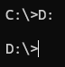

* Navigating to sub folder, simply type “cd **type_path_here**”

